

Invitation

Grand Chapître de Norvège 2026

Ålesund – 28-30 August 2026

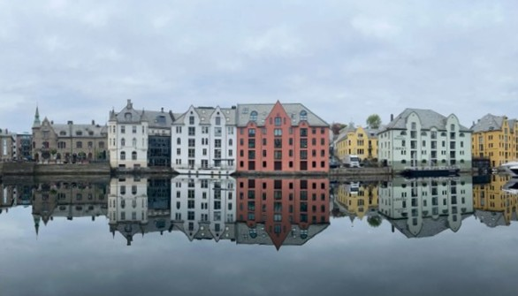

Chères Consœurs, Chers Confrères
Welcome to Norway and Ålesund, one of the country’s most distinctive coastal towns.
A city fire in 1904 laid the foundation for an Art Nouveau city centre that today forms a coherent and vibrant urban space, with details and architecture you won’t find elsewhere in the country. The sea is ever-present throughout the weekend, with Brosundet, quaysides, and views that create a maritime setting for both the ceremonial and the informal gatherings.
Ålesund is an exceptionally good host city for this year’s Grand Chapître, combining short distances, a strong local identity, and a culinary scene with direct access to ingredients from the sea. The programme is built around great flavours, clear Chaîne content, and good meeting places. Most events are within a comfortable walking distance of the host hotel.
REGISTRATION
Registration is now open. We hope you will join us, and we recommend registering early, as several events have limited capacity.
Registration deadline: 30 April 2026
REGISTRATION
Please specify any allergies and other requirements in the comments field when registering.

PROGRAMME
Subject to printing errors and unforeseen changes

FRIDAY 28 AUGUST 2026
3:00 pm to 6:00 pm
Welcome Desk | Registration and information
Thon Hotel Ålesund
Here you can register your arrival, collect any event materials, and ask questions about the programme, dress code, meeting points, and practical arrangements.
7:30 pm
Get Together | Culinary and food history evening with Nesjemat
Aalesund Klubselkab
Price: Member 2,145 kr | Guest 2,245 kr
Dress code: Dark suit with chain
Vice Conseiller Culinaire Nils Henning Nesje, Managing Director and chef at Nesjemat, will host the evening. Nils Henning has worked to promote locally sourced food for many years, long before the concept became widely established. This is our opportunity to experience him at his best, in collaboration with Vice Chargé de Presse Kari Bjørnø Vangen, who will contribute as co-host for the evening.
How to get there
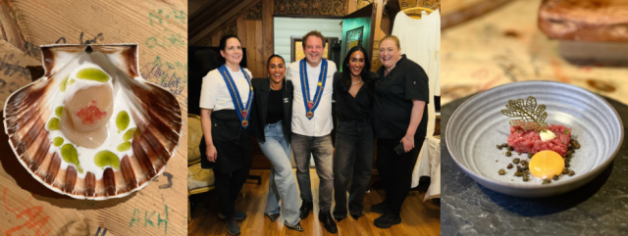
The evening concludes with coffee and mingling in the bar at Thon Hotel Ålesund, where we can enjoy the beautiful view of the sea.
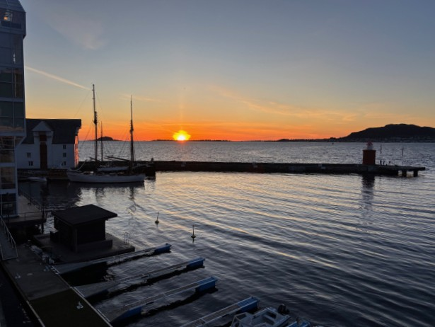

SATURDAY 29 AUGUST 2026
10:30 am
Annual General Meeting of Bailliage de Norvège
Thon Hotel Ålesund
Dress code: Smart casual with chain
The Annual General Meeting is the formal yearly meeting of Bailliage de Norvège and an important arena for influence and anchoring within the organisation. You will receive an update on the past year’s work and activities, finances, and key matters affecting both members and bailliages. There will also be time for questions, input, and discussion. The meeting is open to all members and provides a good opportunity to get a full overview and help shape the direction we set going forward.
10:30 am
Guided city walk with Per Giskeødegård
Meet in the lobby at Thon Hotel Ålesund
Price: Member 200 kr | Guest 250 kr
Dress code: Smart casual, comfortable shoes. Outerwear according to the weather.
The city walk offers a lively introduction to Ålesund as an Art Nouveau city and a coastal town. We will walk at a relaxed pace through central neighbourhoods and hear the stories behind the architecture, the city fire of 1904, and the rebuilding that gave Ålesund its distinctive character. Along the way you will experience viewpoints and small details that help you see the city with fresh eyes. The walk is equally suitable for first-time visitors and for those who have been to Ålesund before, and it provides a pleasant social start to the day ahead of lunch.
Note: The Annual General Meeting and the city walk take place at the same time. You choose one of the options when registering.
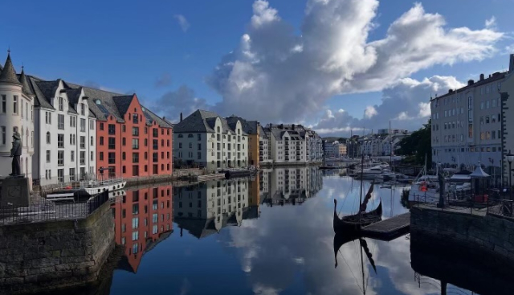
12:30 pm
l’Ordre Mondial lunch at Sjøbua
Price: Member 1,645 kr | Guest 1,745 kr
Dress code: Smart casual with chain and OMGD ribbon
Sjøbua serves local seafood at Brosundet in Ålesund. Ever since the narrow sound was a bustling fishing harbour, food lovers have come here to secure the best ingredients. Sjøbua blurs the line between bistro and fine dining. The atmosphere will be relaxed yet refined. We will enjoy a four-course menu with carefully selected wines.
How to get there
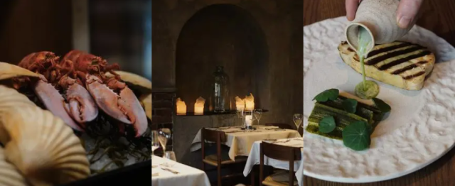
12:30 pm
l’Ordre Mondial lunch at Fisketorget Delikatesse
Price: Member 1,650 kr | Guest 1,750 kr
Dress code: Smart casual with chain and OMGD ribbon
Fisketorget Delikatesse invites you to a newly renovated restaurant with a new bar. The menu features seafood and other delicacies. We will enjoy a four-course menu with carefully selected wines.
How to get there
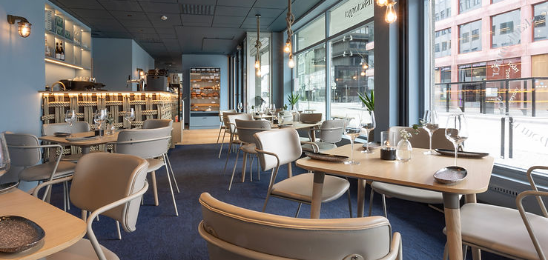
Note: The two l’Ordre Mondial lunches take place at the same time. You choose one of the options when registering.

2:00 pm to 4:00 pm
Welcome Desk | Registration and information
Thon Hotel Ålesund
Here you can ask questions about the programme, dress code, meeting points, and practical arrangements.
5:00 pm
Induction Ceremony
Frimurerlogen
Price: Member 200 kr | Guest 250 kr
Dress code: Black tie with chain
This is this year’s opportunity in Norway to be inducted and receive your chain. Under “Induction Ceremony” in the registration form, select the option that applies to you. If you wish to be inducted into l’Ordre Mondial and are unsure whether you are registered as a member, please contact your Bailli Régional.
Doors open at 4:30 pm. An apéritif will be served before the ceremony. The induction begins promptly at 5:00 pm, and everyone must be seated no later than 4:50 pm. Further information on meeting times for those being inducted will follow.
Reserved seating will be available for inductees.
How to get there
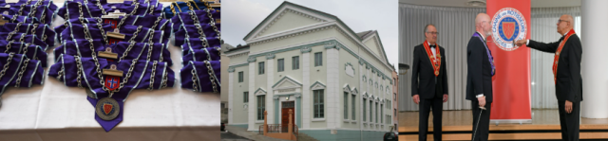
7:00 pm
Apéritif
Thon Hotel Ålesund
Dress code: Black tie with chain
7:30 pm
Grand Dîner
Thon Hotel Ålesund
Price: Member 2,500 kr | Guest 2,600 kr
Dress code: Black tie with chain
Thon Hotels invests in skills development and collaborates with outstanding chefs to ensure quality down to the smallest detail. Their team includes Bocuse d’Or silver medallist Filip August Bendi. Thon Hotel Ålesund’s F&B team, in collaboration with Aleksander Vartdal, silver medallist in Årets Kokk 2023, has created a seven-course menu featuring local ingredients. Dinner will be served with a beautiful view of the sea.
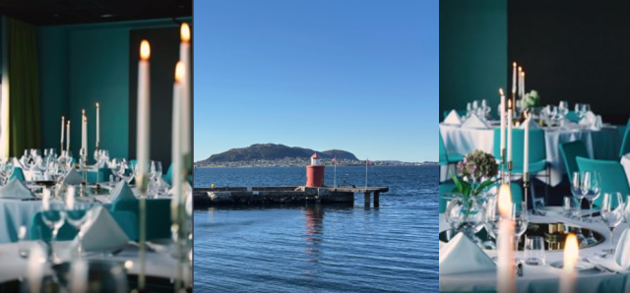
SUNDAY 30 AUGUST 2026
12:00 pm
Farewell lunch at Vino Bar
Price: Member 1,100 kr | Guest 1,200 kr
Dress code: Casual with chain
Vino Bar offers a wine list of more than 2,000 wines from most of the world’s wine regions and was named “BEST WINE BAR LIST IN THE WORLD” in 2024.
We can look forward to experiencing a great combination of wine and sushi.
How to get there
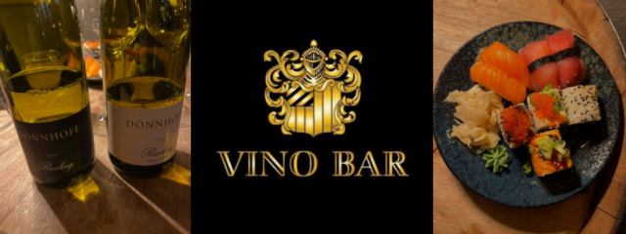

TRAVELLING TO ÅLESUND
Flights
Ålesund Airport Vigra. Airport coach, taxi, or Uber to the city centre.
Car
Parking is available near the hotels.
Train
The nearest train station is Åndalsnes. Continue by bus to Ålesund (about 2.5 hours).
Boat
Hurtigruten and Havila Kystruten can be good options along the coast.

STAYING IN ÅLESUND
Thon Hotel Ålesund
Special rate on a limited number of rooms. The offer is valid until 1 April 2026.
Click here for booking
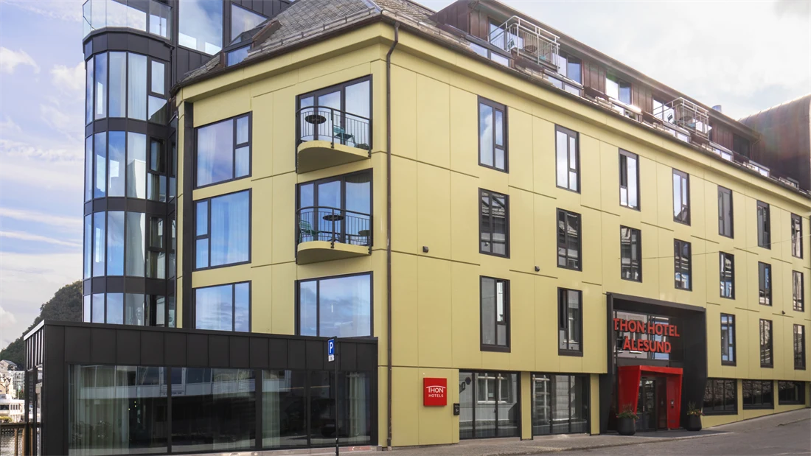

Hotel Brosundet
Special rate on a limited number of rooms. The offer is valid until 31 Mai 2026.
Click here for booking
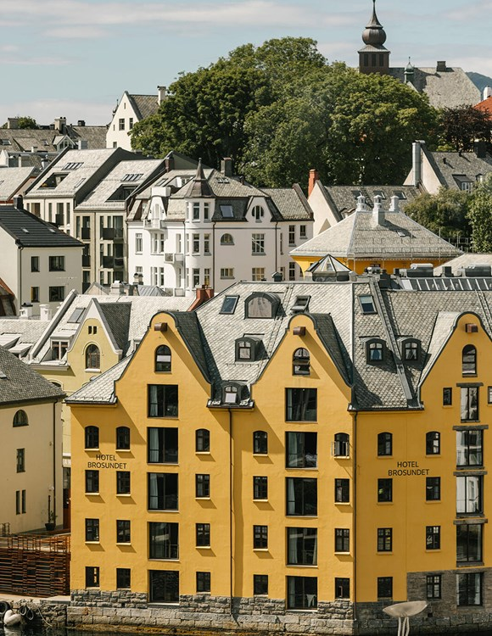

A warm welcome to memorable days in Ålesund!
Kind regards,

Conseil Régional de Nordvestlandet

Chaine.no
