Young Sommeliers Awards Dinner 2026

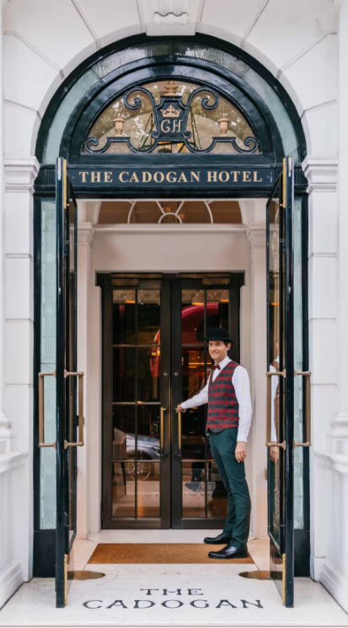
Sloane Street, London
Friday 15 May 2026

Dear Members and Friends

A great opportunity to meet your friends again from across the country and to support our industry and its young talent in this superb hotel.
Belmond’s sister hotel to Le Manoir aux Quat Saisons.

The next generation of young professionals is the lifeblood of our renowned hospitality industry. It is vital that we all nurture fresh talent and encourage ‘careers in hospitality’ and, as the world’s oldest fine-dining association, the Chaîne des Rôtisseurs, takes its role very seriously in this respect. Each year, we are proud to encourage young professionals to raise their standards by training for, and competing in, our international competitions.

We also encourage all Chaîne members and the employers of these young people to come and support the finalists from our two competitions. The winners will be announced together with the award of the Gerard Basset Tasting Trophy to the best young sommelier in the Blind Tasting and Food Matching section of the competition.

We will also be delighted to welcome our judges to the Awards, who will be giving us their feedback as to the superb quality of entrants that the 2026 Awards have attracted from across the industry. We are sure that many of you will wish to support these young people and enjoy this exclusive and highly prestigious event.

The Cadogan team lead by General Manager, Maitre Hotelier Russell Platt and Executive Chef, Michael Turner will be doing us proud.

Those wishing to support our candidates at the International Finals, the dates are 14-18 October in Båstad, Southwest Sweden.

I very much look forward to welcoming you to this inspirational and fun event that supports the heart of our industry.

With warmest regards

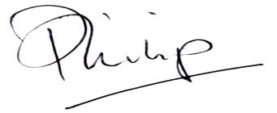
Philip Evins
Bailli Délégué
Membre du Conseil Magistral



Reception

Kleine Zalze Cape Classique 2019
Canapes

Dinner

Artichoke & truffle salad
truffle cream and lemon
Chapoutier, Alchemy Souffle de Solaure
Coteaux de Die, Clairette Blanche 2022

*****

Roasted Monkfish with caramelised sweet potato
Vadouvan & Coriander
Cherubino, Great Southern, Laissez Faire Riesling 2023

******
Herb crusted rack of lamb
golden pomme anna, tomato, olive & basil sauce
Robert Oakley, Margaret River,The Pentland,
Cabernet Sauvignon 2017
*****

AWARDS

*****

Hazelnut & chocolate Delice
crunchy praline, salted caramel, chocolate sponge,
hazelnut & milk chocolate mousse, hazelnut ice cream
Zuccardi, Uco Valley, Malamado NV

******

Tea, Coffee and Petit Fours

Booking form
Friday 15 May 2026
The Cadogan Hotel, London
19.00 Reception for 19.45 Dinner

Dress code
Black Tie and Evening/Cocktail Dresses with full Chaîne regalia

Dinner – Jeune Members £140 / Members £170 / Guests £185
Members Names |  |  | Amount
Guests Names

Payment options (select your preferred payment option) Payment no later than 5 May 2026
Option 1: Bank Transfer
Branch Sort Code: 40-46-39
Account Number: 41793772
Account Name: O.M.G.D.
Payment Ref: Give your name

Option 2: Cheque
Make payable to “O.M.G.D.” and post with a copy of this form to
Steve Conway, Uplands, Sonning Lane, Sonning, Reading, Berkshire RG4 6ST
Whichever payment option you select, please return a completed Booking Form by email
to bd@chaine.co.uk and gbevents@chaine.co.uk

